o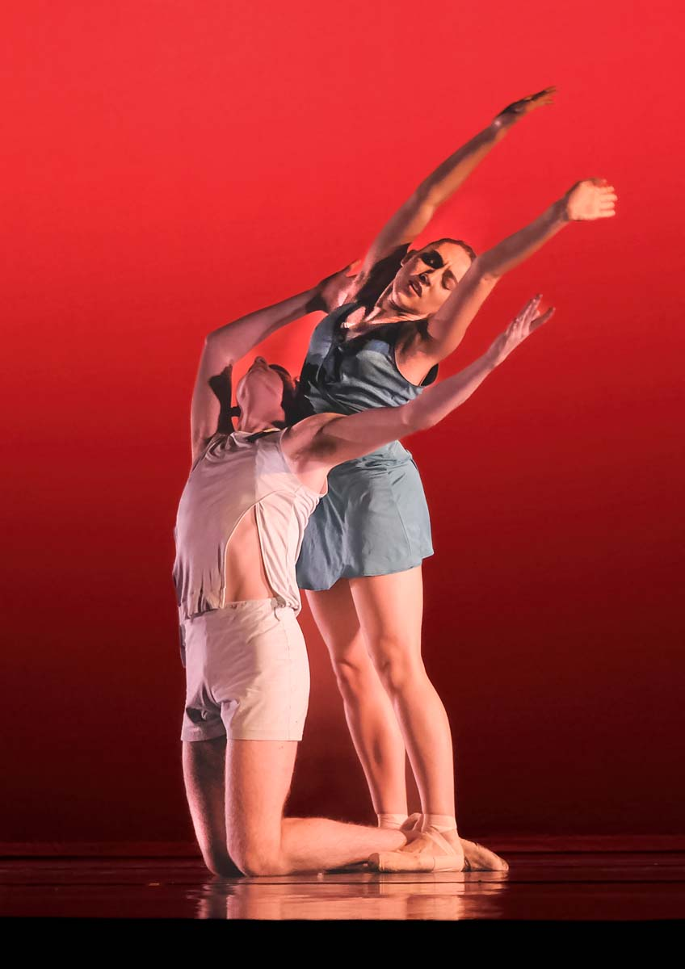
Newbury Photography Club

Programme for 2023/2024
www.newburyphotographyclub.uk

Club Officers and Committee
President President | Alan Teece  ba.teece@talktalk.net
Chairman | Andrew Buchanan  chairperson@newburyphotographyclub.uk
Treasurer | Paul Holdaway  treasurer@newburyphotographyclub.uk
Secretary | Vacancy  secretary@newburyphotographyclub.uk
Internal Competition Secretary | Gina Robinson - 07557378831  compsecretary@newburyphotographyclub.uk
Programme Secretary | Alvin Webb- 07786 834652
External Competition Secretary  Social Media | Andrew Buchanan- 07776 100356  compsecext@newburyphotographyclub.uk  Kevin Sheldrake- 07768460258  kevinm.sheldrake@gmail.com
Committee  support | Mike Stevenson 07966 272515  Rob Carpenter 07760 151732
We meet at the Phoenix Resource Centre at 212 Newtown Rd, Newbury RG14 7EB.
Thursday evenings from 7pm for a prompt start at 7.25pm
Founder
Jack Hole
Past Presidents
Paul Sefcick, Richard Summersby FRPS, Jim Irving, Richard Froud ARPS,
Honorary Life Members
Hermon Dowling ARPS, Richard Pike LRPS,
Paul Sievers ARPS

Facebook: https://www.facebook.com/NewburyPC/

Twitter: @clubnewbury
Instagram: @newburyphotoclub

Cover Image- with thanks to Alan Teece

Introduction
Everyone is welcome at our meetings. We have a wide range of activities to interest all ages and levels of photographic skills. Our programme includes:
- Talks and presentations on photography by leading professional and amateur photographers.
- Print and Digital image competitions, both internal and with other clubs.
- Workshops and demonstrations of camera and software techniques.
- Informal gatherings, special interest groups and social events.
- A summer season of less formal meetings in June, July and August.
The club is a member of the Southern Counties Photographic Federation. We enter competitions with other clubs in the Federation and enter the Federation’s annual exhibition.
We pride ourselves in catering for all standards of photography, and in helping members to learn and to get the most enjoyment from photography.

Meetings are every Thursday from 7pm for 7:25pm start.

Membership
Annual Membership rates are £100 single members and £190 joint members. £35 for concessionary & junior members (under 18 years). Visitor’s fee is £3 per evening.

Internal Competitions – Members Only
Internal competitions this Season are arranged in a single League.

This season’s Internal League has 3 rounds of up to 3 prints and PDI images per Member per round, all scores count. Competition prints must be mounted and preferably in 50cm x 40cm mounts but other sizes can be used, a PDI is also required. PDIs use sRGB colour space in JPG format and are resized as 1600 x 1200 pixels for landscape and 1200 high for portrait.

Upload competition PDIs for Prints and PDIs on the PhotoEntry system at least one week before the competition date.

PDI File Naming Convention
Title Author name.JPG
2023-24 Programme
7 Sept | Presentation night | Competition winners and runners up.
14 Sept | Informal Evening/ Project Presentation night | Follow up from the summer Project evenings
21 Sept | Dorset and Beyond | Emily Endean via Zoom
28 Sept | Safe sensor cleaning  Practical Evening | Peter Brogden  Just Ltd
5 Oct | Members Meeting | Support, Workshop, and social evening
12 Oct | Critique Evening  Prints and PDIs | SCPF Judge: Dr Paul Hendley
19 Oct | Stereo Photography | Ian Wallace
26 Oct | Best B&W Print, Panel of 3  Related B&W Prints and Best Colour Print (Flora) | Judge: Ashley Francis
2 Nov | Shooting NASA | Steve Smyth
9 Nov | Members Meeting | Support, Workshop and Social evening
16 Nov | Internal Competition  Prints Round 1 | Judge: Steve Kirkby
23 Nov | Namibia – a flying and climbing adventure. | Ashley Francis  Theatre
30 Nov | Internal Competition  PDIs Round 1 | PDI Theme: Autumn  Judge: Peter Crane
7 Dec | SCPF League-Projected  Digital Images Div. 3. | SCPF Judge: Jason Hyde
14 Dec | Architecture | Richard O’Brien via Zoom
21 Dec | Christmas Social | Social Event  Ground floor dining room
28 Dec | CHRISTMAS -NEW YEAR BREAK | Closed
4 Jan | Members Meeting | Support, Workshop and Social evening
11 Jan | Internal Competition  Prints Round 2 | Judge: Glyn Paton
18 Jan | A visual signature | Andrew Phillips via Zoom
25 Jan | Street Photography | Peter Crane
1 Feb | Critique Evening  Prints and PDIs | SCPF Judge: John Randall
8 Feb | A Falklands experience. | Mike Cullis
15 Feb | Members Meeting | Support, Workshop and Social evening
22 Feb | SCPF League Print  Div 2 | SCPF Judge: Peter Orr  Theatre
29 Feb | The Work of David Rutter | David Rutter
7 Mar | Members Meeting | Support, Workshop and Social evening
14 Mar | Internal Competition  PDIs Round 2 | PDI Theme: Open  Judge: Eddy Lane
21 Mar | Newbury Challenge Plate | External Competition  Judge: Peter Crane  Theatre
28 Mar | Travel & Macro competitions  Judges: Hermon Dowling ARPS, Paul Sievers ARPS | Internal Print (Travel) and  PDI (Macro) Competitions
4 Apr | Members Meeting | Support, Workshop and Social evening
11 Apr | Annual Dinner | TBA
18 Apr | Internal Competition  Prints Round 3 | Judge: Dr Paul Hendley
25 April | Composite Images | Sharon and Robert Prenton Jones via Zoom
2 May | Local Election | Closed
9 May | Internal Competition  PDIs Round 3 | PDI Theme: Open  Judge: Jason Hyde
16 May | Mobile Phone Competition | Judged by members
23 May | President’s Evening | TBA
30 May | Annual Travel Lecture | Landscapes for all Seasons  Robert Harvey
 |  | Theatre

2024 Summer Programme

The Summer programme will start on Thursday June 6th and run until Thursday August 29th. Details of this programme will be provided later, including the date of the AGM. The 2024-25 Season will start on Thursday September 5th.

Club Speciality Competitions
Best Flora Colour Print | Best print close-up of a plant, leaf, or flower.  Taken “In Situ”.
Best Panel of 3 | Best Panel of Three Related Black and White Prints
Travel Picture Competition | Best Colour Print
Macro Competition | Best Colour PDI
Best Black & White  Mobile Phone | Best Black and White Print  Open subject.
Most Improved Photographer of the Year | Most Improved photographer over the last year voted on by Committee
The Newbury Challenge Plate | A competition between up to nine clubs from the Southern Counties Photographic Federation

GDPR
Our Data Protection Policy is available on our Website.

